**Raspberry Pi Zero 2 3 B+ Audio Sound Card Module I2S**

**(Fe-PI DAC)**

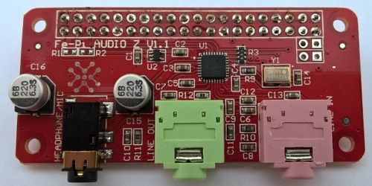

The Fe-Pi Audio Z sound card is designed to provide a complete low cost audio solution for Raspberry Pi 2, 3, and Zero, needing line-in, line-out, and headphone-out/mic-in.

Small Raspberry Pi Zero PCB footprint.

SGTL5000 low power stereo codec.

3.5 mm, 4 contact, jack for Headphone/MIC (black).

3.5 mm jack for stereo Line Out (green), and stereo Line In (pink).

ADC > 90 dB SNR and -72 dB THD+N

Line-Out > 100 dB SNR and -85 dB THD+N

HP Output > 100 dB SNR and -80 dB THD+N, 62.5 mW max into 16 ohm.

Hardware level controls for Headphone Volume, Line In, Line Out. ALSA support.

2x20pin 2.54mm female header soldered to board. (Add note at checkout to ship without 2x20pin header soldered to board)

40pin male breakable header for your Raspberry Pi Zero included!

Setup and Support can be found [here.](http://fe-pi.com/p/support-and-setup)

<http://fe-pi.com/p/support-and-setup>

Save yourself some effort and “read” the 1st line of the setup text

## **SETUP AND SUPPORT**

Fe-Pi Audio board driver code are now in the official Raspberry Pi kernel since v4.9.13

Trust me I didn’t see it, and spent hours trying to get it to work with WIFI, and only a few minutes installing the current raspberry pi image from raspberrypi.org (and updating it)